DEPLOYING AD LAB IN AZURE

# Pre-requisites

To successfully deploy this lab into Azure following items are required

* Access to Azure Subscription
* An Azure Resource Group separate from any other deployments
* And existing Virtual Network(VNET) with at least one Subnet connected to on-premise network either via Express Route or a VNP
* An existing Azure Storage Account
* Permissions to create VMs in the resource group (VM Contributor Rights at least)
* Permissions to attach NIC resource to Subnet in the Virtual Network (VM contributor rights to the VNET at least)
* Permissions to create containers, generate keys and write files to Storage Account (Storage Account Contributor rights)
* Latest Azure Powershell Module installed on deployment workstation
* Text editor like Notepad ++ or Visual Studio IDE

# Preparation for deployment

## Identify deployment environment

1. Launch powershell windows and insure that Azure module is installed by running command: ***Import-Module azure***
2. Login to Azure by running command: ***Login-AzureRMAccount*** . Provide credentials as prompted.
3. Verify you are in the correct subscription by running command: ***Get-AzureRMSubscription***

If you see more than one subscriptions listed, copy ID of the subscription you want and run command: ***Select-AzureRMSubscription -SubscriptionID <id of the subscription you copied>***

1. Get a list of resource groups in the subscription by running command: ***Get-AzureRMResourceGroup | select Name,Location*** . Make a note of the Resource Group and location for the resource group you are planning to use, you will need this later.
2. Get a list of Storage Accounts in the subscription by running command: ***Get-AzureRmStorageAccount | select StorageAccountName,ResourceGroupName*** . Make a note of the name of the Storage Account you are going to use and resource group, you will need this later.
3. Get a list of virtual networks in your subscription by running command : ***Get-AzureRmVirtualNetwork | select Name,ResourceGroupName*** . Make a note of the name of the of VNET you are going to use and the Resource Group where the Virtual Network is located.
4. Get a list of available subnets in the VNET you select by running command : ***Get-AzureRmVirtualNetwork -name <your vnetname from step 6) -ResourceGroupName <your resource group from step 6> | select -ExpandProperty subnets | select name*** . Make a note of the name of the of subnet you are going to use

## Prepare for deployment

Unzip provided ADSimpleLab to the root of the drive.

Using Windows Explorer navigate to folder templates and open azuredeploy.parametrs.json with text editor:

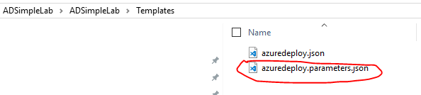

In the editor locate following entries and replace values with information you recorded in the previous chaper:

VirtualNetworkName – VNET name you looked up in the step 6

subnetName – name of the subnet you looked up in step 7

virtualNetResourceGroupName – Resource Group you looked up in the step 6

domainName – Domain name your lab forest in a DNS format <name>.<suffix>

NetBiosDomainname – Netbios domain name, typically derived from first part of the DNS domain name

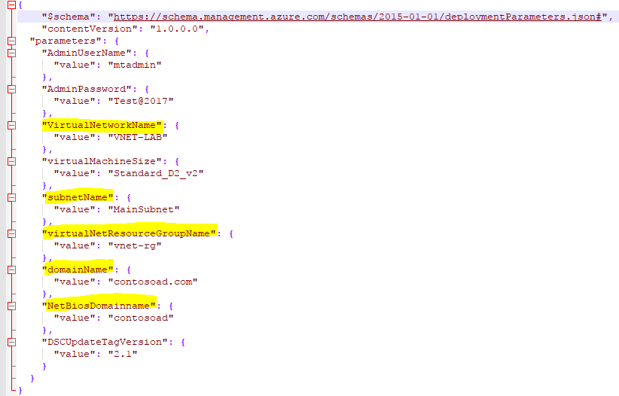

Save the file after you are done editing.

## Deploying the AD lab into Azure

On the powershell prompt to navigate to the “scripts” folder in the extracted lab project

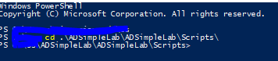

Type following command: **.\Deploy-AzureResourceGroup.ps1 -ResourceGroupLocation <location from preparation step 4 > -ResourceGroup <resource group from step 4> -UploadArtifacts -StorageAccountName <storage account name from step 5> -StorageAccountResourceGroupName <resource group from step 5> -Verbose .** The full command would look similar to below:

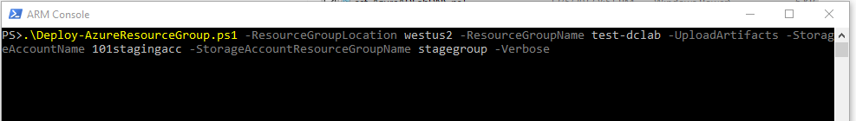

Hit enter and the deployment will start. You should see screen similar to this:

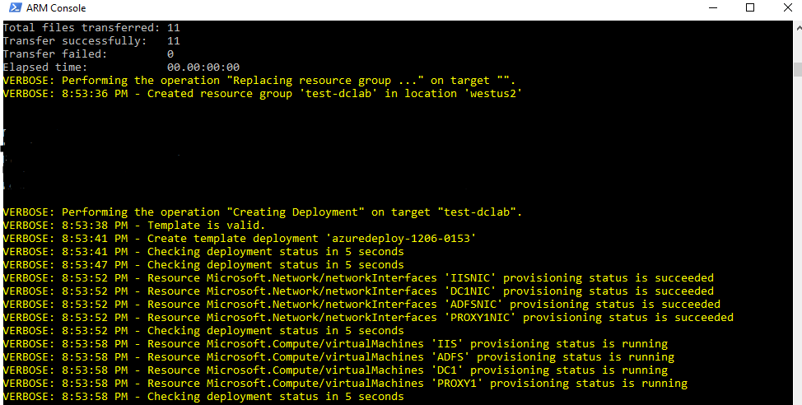

The deployment will create four VMs in the resource group named ADFS,DC1,IIS and PROXY. It will also configure DC1 to be firt

When deployment is completed you will see final output, make sure “ProvisioningSate” says Succeeded.

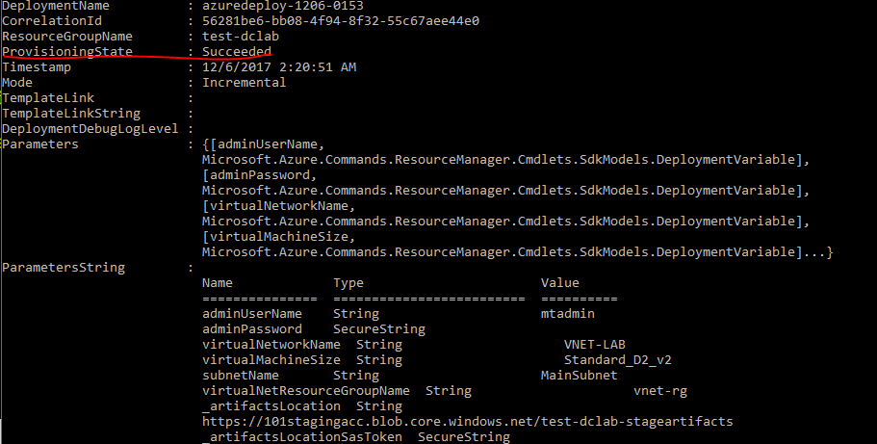

# Post-deployment process

## Configure Domain Controller with static IP address and set DNS on all servers

In this deployment the name of the VM with a role of DC is DC1. This is hardcoded into template azuredeploy.json but can be changed if needed.

To set IP address of the DC1 to static and to set DNS servers on other VMs you can run a custom script located in the same folder as the deployment script from the previous chapter. To run the script type following command and hit Enter :

***.\set-AzureADLabDNS.ps1 -ResourceGroupName <name of the resource group from step 4 in preparation chapter) -DCName DC1 -Verbose*** .

You will be prompted to review list of affected VMs as well as name of the resource group and subscription. WARNING! Please review very carefully and make you only see VMs you intend to update.

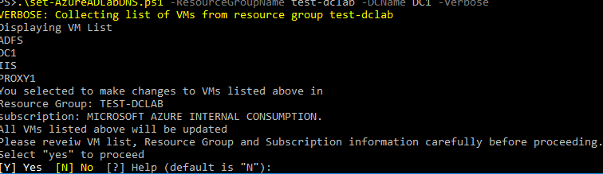

When ready to proceed type “Y” and hit enter. After script complete to run it will display list of VMs and IP addresses.

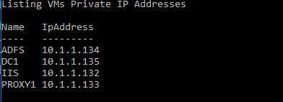

To complete lab set up use the IP addressed to connect to servers via RDP and complete ADFS installation and configuration.